**Python for Data Science:**

**Module-2**

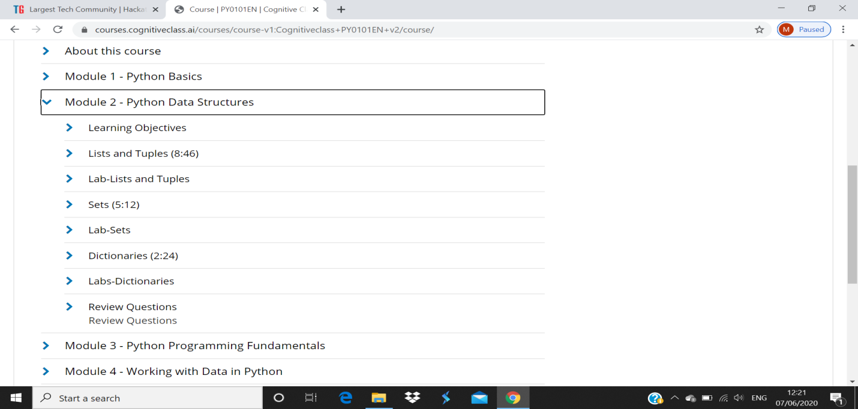

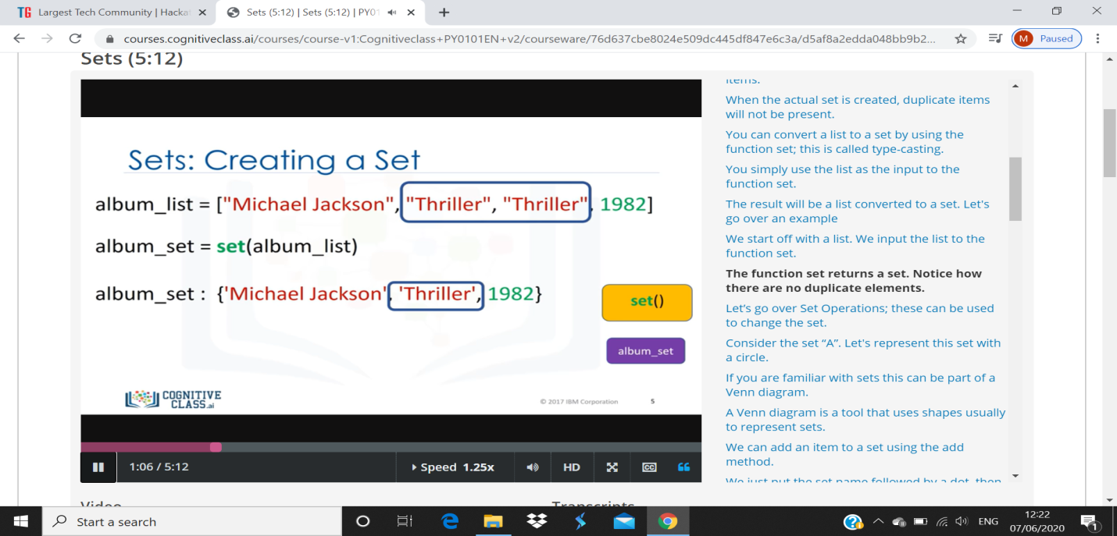

1. To define a set, you use curly brackets You place the elements of a set within the
2. curly brackets. You notice there are duplicate items.
3. When the actual set is created, duplicate items will not be present.
4. You can convert a list to a set by using the function set; this is called type-casting.
5. You simply use the list as the input to the function set.
6. The result will be a list converted to a set. Let's go over an example
7. We start off with a list. We input the list to the function set.
8. The function set returns a set. Notice how there are no duplicate elements.